Dear children and teenagers,
We would like to warmly welcome you as participants of the International Learning Village in Statenberg/Slovenia!
All in all there will be around 25 of you between 1 to 17 years of age (and many more 'so-called' grown-ups).
We are hoping we will all have lots of fun and good quality time together!
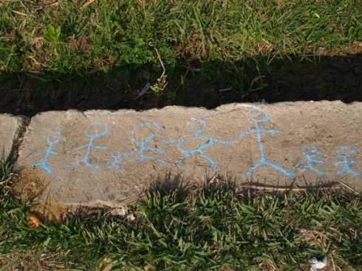
Before you set off on your journey, we want to give you a short update on the plans for the week and some background information.
THE MANOR …
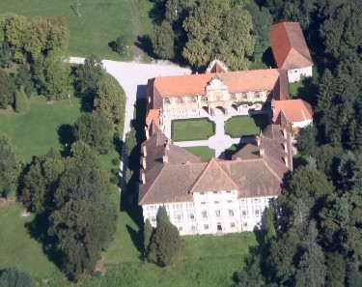
… is an old castle with lots to explore in an around! It is located in the middle of a forest and meadows and it looks fantastic. Whoever wants to will be able to explore the castle and the surrounding nature together. (The weather forecast is good).
YOUR PLACE IN THE LEARNING VILLAGE…
… is everywhere in principle. We will start the day together with all participants, and we will close it together as well. Meals are also taken together. For the time when the parents are working, you are welcome to join and contribute, especially for the older ones.
At the same time, there will be a “kids' room” that is always open for you. This room will always have something to drink and some fruits or biscuits. We will also place things to paint, read, and work in this room.
SOMEONE YOU CAN ALWAYS TURN TO …
Apart from your parents, there are some people that you can always turn to. Uli will be one of them …
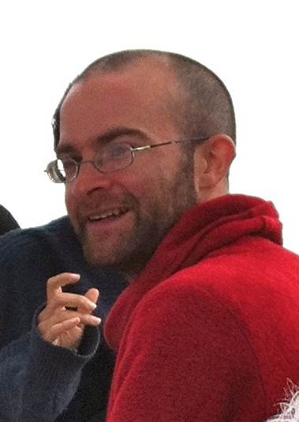
Uli - 43 years old, mother of Aisha (9), lives in Cairo & Munich, likes mountains and elephants;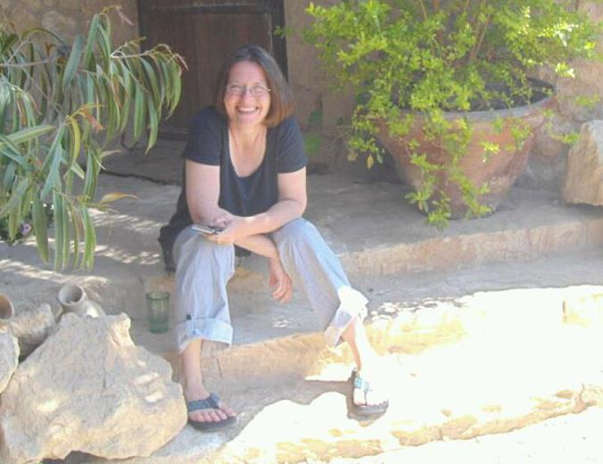
and maybe Dave (tbc)

BRING YOUR IDEAS ...
… on how to spend this week together. We are counting on your ideas, projects and plans.
What would be fun/interesting/inspiring to do and explore together?
Parents and other adults will bring some material and sports equipment, but we are also asking you to consider what you’d really like to bring with you.
With all of that – we wish you a pleasant journey and look very much forward to meeting you all!

